.
HYDRATE!  Use this calendar to record your progress. You may have the goal of a certain number of oz or less soda, whatever your goal, keep track here! | 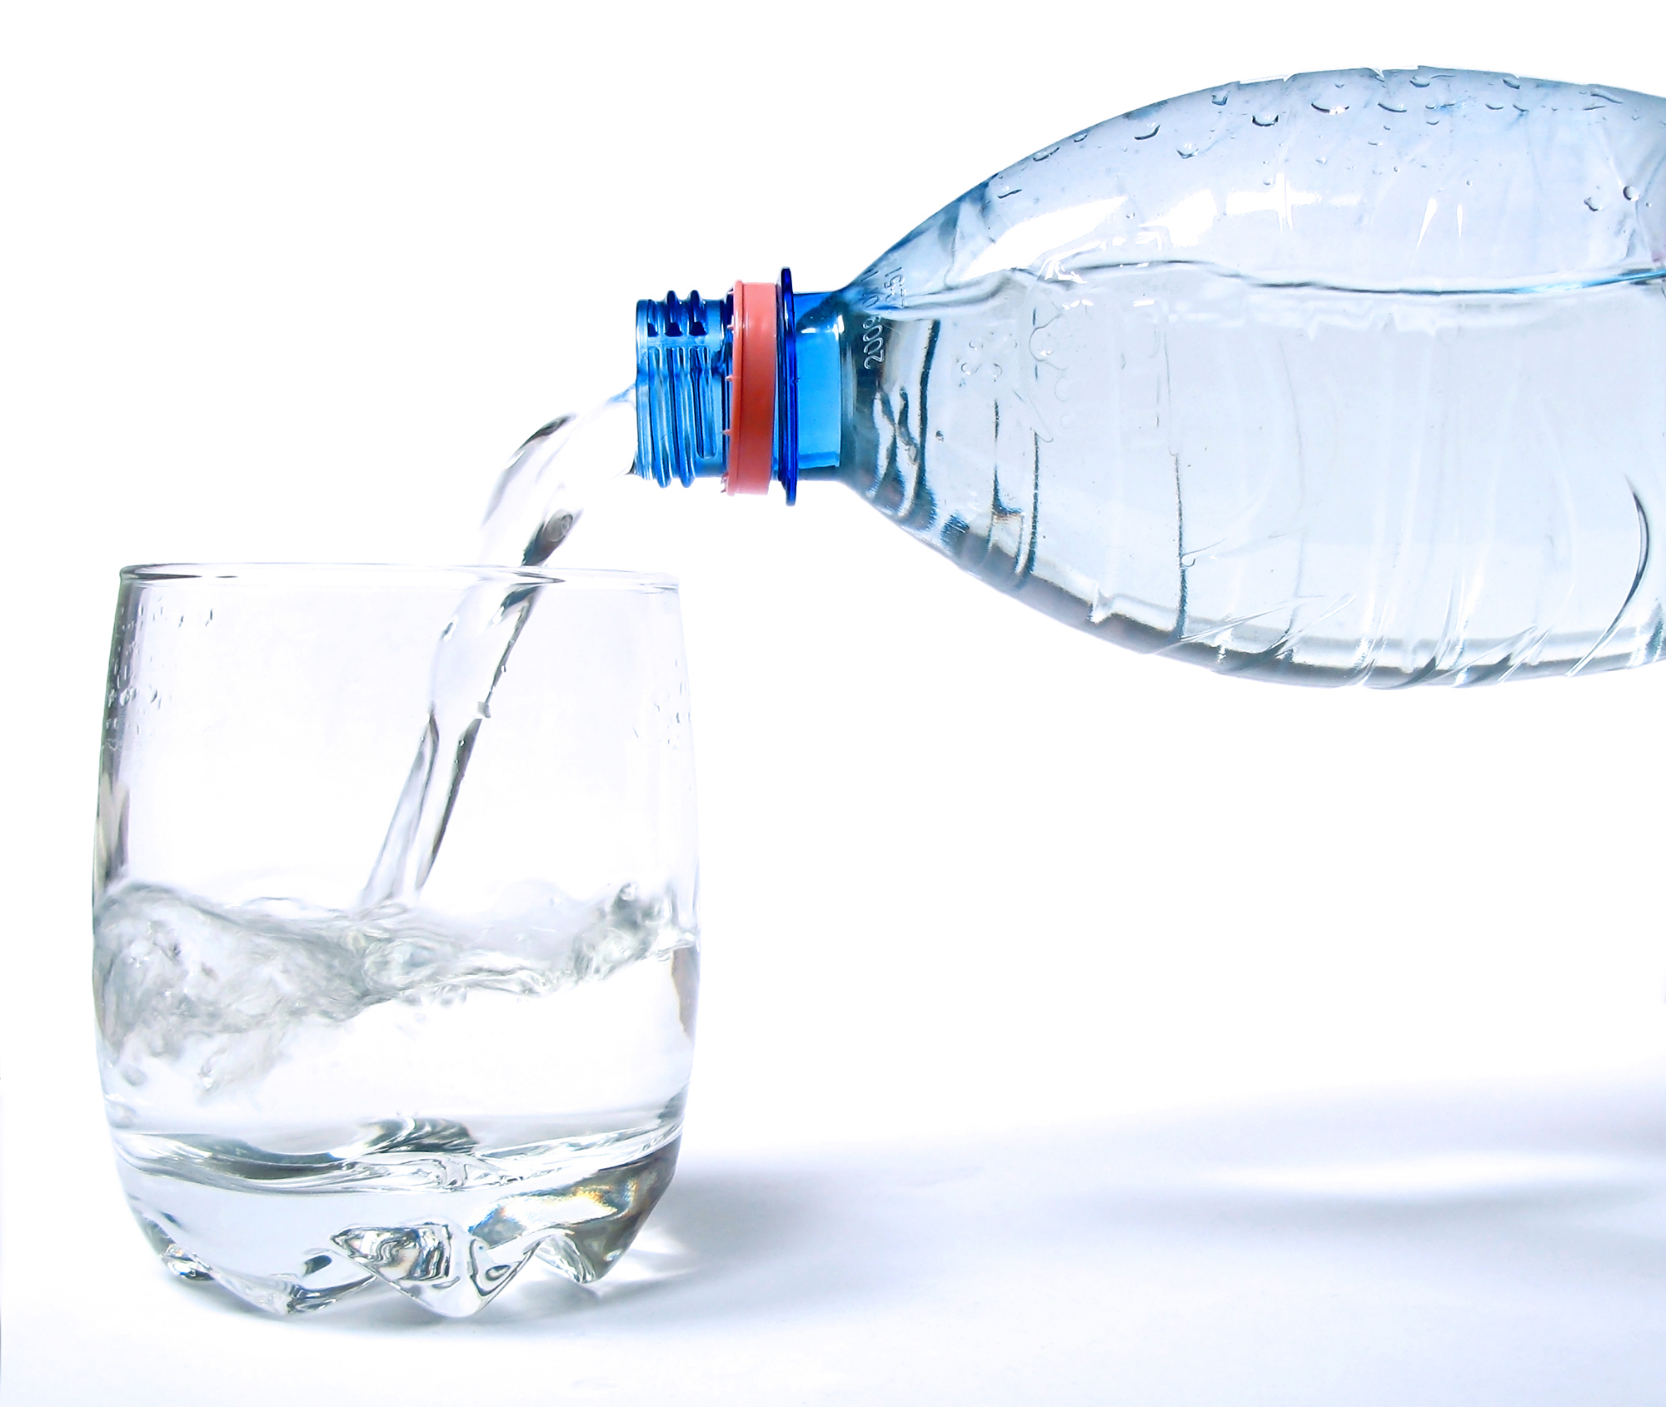
Sun. | Mon. | Tue. | Wed. | Thu. | Fri. | Sat.
 |  |  |  | 30 | 31 | 1
 |  |  |  | START!
2 | 3 | 4 | 5 | 6 | 7 | 8
9 | 10 | 11 | 12 | 13 | 14 | 15
16 | 17 | 18 | 19 | 20 | 21 | 22
 |  |  | YOU DID IT!
23 | 24 | 25 | 26

HYDRATE | Every single cell in your body depends on water to operate properly (not drinks laden with sugar, caffeine or other ingredients)! You can survive a month without food, but only about 3 days without water.

