6-Week Advanced
5K Training
Open Track Times: 6:30am-8:45am and 3:00pm-4:00pm on Tuesdays and Thursdays
Stretches: Warm up by jogging 3-5 minutes before stretching and stretch after your workout when your muscles are warm.
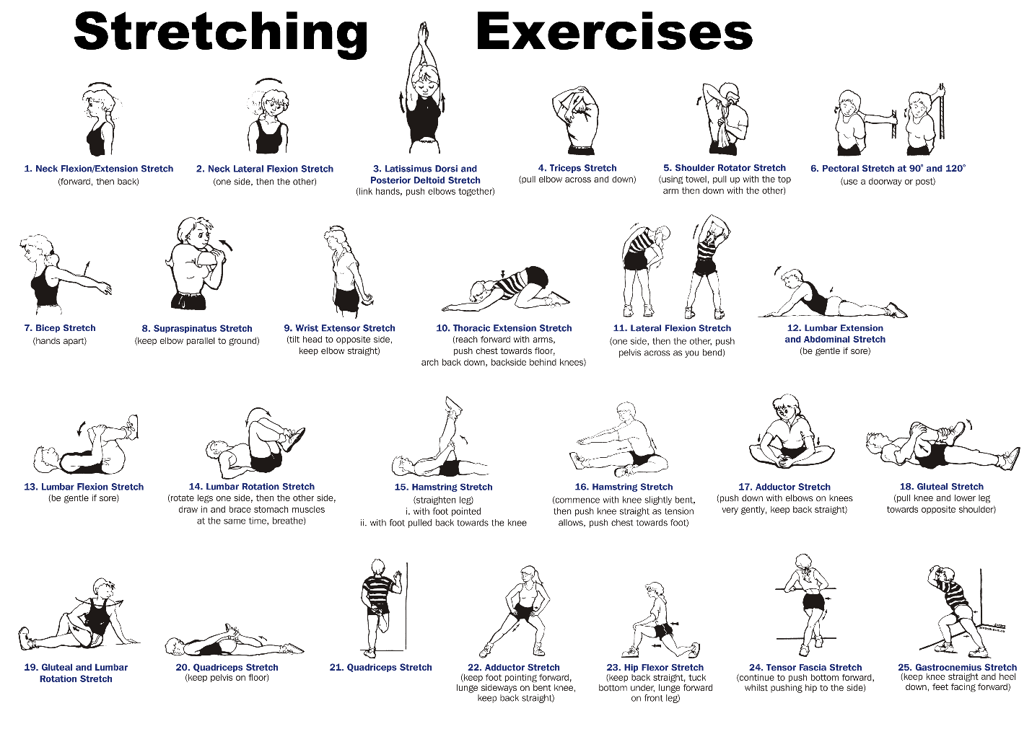
Strength Training: Strength training can be floor exercises, resistance bands, free weights, machines, and/or yoga. Combining light weights with a high number of repetitions is better than pumping very heavy iron.
Hydration/Nutrition: Hydration, hydration, hydration. Don’t wait till you’re thirsty to hydrate your body. Drink water prior to working out. Your body also needs balanced nutrition. Top food choices for runners:
Bananas
Berries
Peanut butter
Broccoli
Low fat yogurt
Skim milk
Lean beef
Salmon
Oatmeal
Whole wheat pasta
Week 1
Monday: Cross train or rest.
Tuesday: 4 x 400 Interval workout. 4 hard 400 meters with a jogging or walking 400 recovery in between.
Wednesday: 4 mile run.
Thursday: 30 minutes with 5 to 10 minutes easy running followed by 15-20 minutes at a pace that is comfortably hard then follow with a 5 to 10 minute cooling down.
Friday: Rest.
Saturday: 5 mile run.
Sunday: 35 minutes at an easy comfortable pace.
Week 2
Monday: Cross train or rest.
Tuesday: 4 x 400 Interval workout. 4 hard 400 meters with a jogging or walking 400 recovery in between.
Wednesday: 4 mile run.
Thursday: 30 minutes with 5 to 10 minutes easy running followed by 15-20 minutes at a pace that is comfortably hard then follow with a 5 to 10 minute cooling down.
Friday: Rest.
Saturday: 6 mile run.
Sunday: 35 minutes at an easy comfortable pace.

Week 3
Monday: Cross train or rest.

Tuesday: 5 x 400 Interval workout. 5 hard 400 meters with a jogging or walking 400 recovery in between.
Wednesday: 5 mile run.
Thursday: 30 minutes with 5 to 10 minutes easy running followed by 15-20 minutes at a pace that is comfortably hard then follow with a 5 to 10 minute cooling down.
Friday: Rest.
Saturday: 7 mile run.
Sunday: 40 minutes at an easy comfortable pace.
Week 4
Monday: Cross train or rest.

Tuesday: 6 x 400 Interval workout. 6 hard 400 meters with a jogging or walking 400 recovery in between.
Wednesday: 5 mile run.
Thursday: 35 minutes with 5 to 10 minutes easy running followed by 15-20 minutes at a pace that is comfortably hard then follow with a 5 to 10 minute cooling down.
Friday: Rest.
Saturday: 8 mile run.
Sunday: 45 minutes at an easy comfortable pace.
Week 5
Monday: Cross train or rest.

Tuesday: 6 x 400 Interval workout. 6 hard 400 meters with a jogging or walking 400 recovery in between.
Wednesday: 5 mile run.
Thursday: 35 minutes with 5 to 10 minutes easy running followed by 15-20 minutes at a pace that is comfortably hard then follow with a 5 to 10 minute cooling down.
Friday: Rest.
Saturday: 9 mile run.
Sunday: 40 minutes at an easy comfortable pace.

Week 6
Monday: Cross train or rest.

Tuesday: 6 x 400 Interval workout. 6 hard 400 meters with a jogging or walking 400 recovery in between.
Wednesday: 5 mile run.
Thursday: 40 minutes with 5 to 10 minutes easy running followed by 15-20 minutes at a pace that is comfortably hard then follow with a 5 to 10 minute cooling down.
Friday: Rest.
Saturday: 8 mile run.
Sunday: 40 minutes at an easy comfortable pace.
Race week:
Monday: Cross train or rest.

Tuesday: 3 mile run.
Wednesday: 30 minute with 5 to 10 minutes easy running followed by 15-20 minutes at a pace that is comfortably hard then follow with a 5 to 10 minute cooling down.
Thursday: Rest.
Friday: Rest.
Saturday: 5K

