6-Week Beginner
5K Training
Open Track Times: 6:30am-8:45am and 3:00pm-4:00pm on Tuesdays and Thursdays
Stretches: Warm up by jogging 3-5 minutes before stretching and stretch after your workout when your muscles are warm.
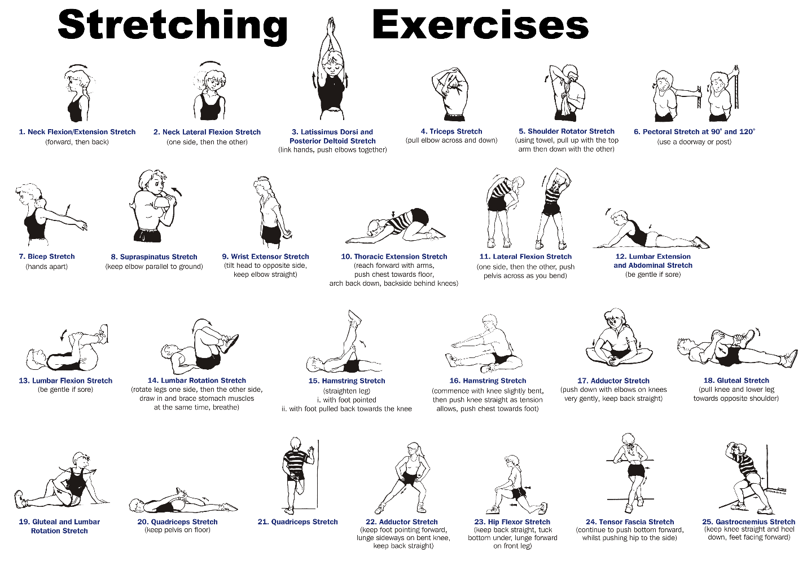
Strength Training: Strength training can be floor exercises, resistance bands, free weights, machines, and/or yoga. Combining light weights with a high number of repetitions is better than pumping very heavy iron.
Hydration/Nutrition: Hydration, hydration, hydration. Don’t wait till you’re thirsty to hydrate your body. Drink water prior to working out. Your body also needs balanced nutrition. Top food choices for runners:
Bananas
Berries
Peanut butter
Broccoli
Low fat yogurt
Skim milk
Lean beef
Salmon
Oatmeal
Whole wheat pasta

Week 1
Monday: Walk briskly for 1 mile. Run 2 minutes every half mile until you reach 3.5 total miles. Walk 0.5 mile.
Tuesday: Walk 3-5 miles.
Wednesday: Rest
Thursday: Walk 1 mile. Run 3 minutes every half mile until you reach 3.5 miles. Walk 0.5 mile.
Friday: Rest
Saturday: Walk 3-5 miles, including 10 run/walk intervals (run 30 seconds, walk 1 minutes) in the last mile.
Sunday: Rest
Week Total: 16-20 miles

Week 2
Monday: Walk 1.5 miles. Run 5 minutes, walk 5 minutes; do 3 times. Walk 1-2 miles.
Tuesday: Walk 3-5 miles.
Wednesday: Rest
Thursday: Repeat Week 1 Thursday.
Friday: Rest
Saturday: Repeat Week 2 Monday.
Sunday: Rest
Week Total: 18-20 miles

Week 3
Monday: Walk 1.5 miles. Run 10 minutes, walk 5-7 minutes, run 10 minutes, walk 5-7 minutes.
Tuesday: Walk 3-5 miles.
Wednesday: Rest
Thursday: Repeat Week 3 Tuesday.
Friday: Rest
Saturday: Walk 1.5 miles. Run 10 minutes, walk 5 minutes, run 5 minutes, walk 5 minutes, run 10 minutes, walk 5-10 minutes.
Sunday: Rest
Week Total: 16-20 miles

Week 4
Monday: Walk 1 mile. Run 3 minutes, walk 2 minutes; do a total of 10 times. Walk 5 minutes.
Tuesday: Walk 1 mile. Run 15 minutes, walk 5 minutes, run 15 minutes, walk 5 minutes.
Wednesday: Rest
Thursday: Walk 1 mile. Run 5 minutes, walk 2 minutes; do that 7-minute sequence 5 times. Walk 5 minutes.
Friday: Rest
Saturday: Walk 1 mile. Run 10 minutes, walk 5 minutes; do that 15-minute sequence 3 times.
Sunday: Rest
Week Total: 17.5 miles

Week 5
Monday: Walk 1 mile. Run 3 minutes, walk 2 minutes; do that 5-minute sequence a total of 10 times. Walk 5 minutes.
Tuesday: Walk 1 mile. Run 20 minutes, walk 5 minutes, run 20 minutes, walk 5 minutes.
Wednesday: Rest
Thursday: Walk 1 mile. Run 5 minutes, walk 2 minutes; do that 7-minute sequence 5 times. Walk 5 minutes.
Friday: Rest
Saturday: Walk 1 mile. Run 15 minutes, walk 5 minutes; do that 20-minute sequence 3 times.
Sunday: Rest
Week Total: 20 miles

Week 6
Monday: Walk 1 mile. Run 3 minutes, walk 2 minutes; do that 5-minute sequence a total of 10 times. Walk 5 minutes.
Tuesday: Walk 1 mile. Run 25 minutes, walk 5 minutes, run 25 minutes, walk 5 minutes.
Wednesday: Rest
Thursday: Walk 1 mile. Run 5 minutes, walk 2 minutes; do that 7-minute sequence 5 times. Walk 5 minutes.
Friday: Rest
Saturday: Walk 1 mile. Run 20 minutes, walk 5 minutes; do that 25-minute sequence 3 times.
Sunday: Rest
Week Total: 22.5 miles

