.
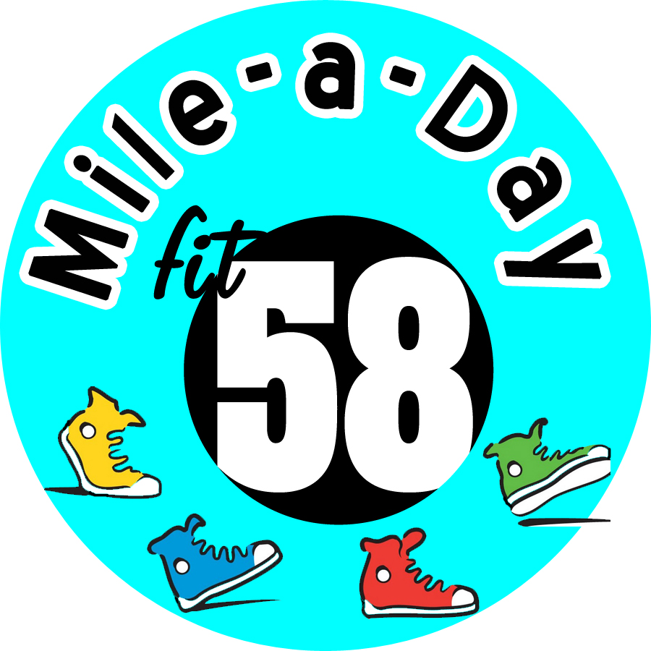
Place an X in the box for each day you walk a mile! (You may also choose to log steps, etc.)
Sun. | Mon. | Tue. | Wed. | Thu. | Fri. | Sat.
 |  |  |  | 30 | 31 | 1
2 | 3 | 4 | 5 | 6 | 7 | 8
9 | 10 | 11 | 12 | 13 | 14 | 15
16 | 17 | 18 | 19 | 20 | 21 | 22
 |  |  | FINISH!
23 | 24 | 25 | 2926 | 30 | 31

Just Walk | Wondering how many laps around your building is a mile? Check out the maps at http://www.58fitness.com/walking-challenge.php. Once you have completed the challenge, please don’t forget to log your progress at http://www.58fitness.com/walking-challenge.php.

